**Assignment No : 1**

Title – Identify and Observe Bad Designs (5 Bad Designs from Website)

Website - <http://www.baddesigns.com>

**Bad Designs**

1. **USB (Cables)**

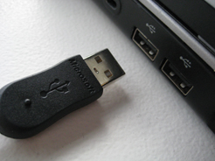

**Problem –**

Many of us face this problem, when we try to insert a USB into a USB Port it does not go in first try but when we look at it carefully and then try, it goes in properly. Even though USB have a symbol/logo on top of it indicating which way it goes in we still forget it.

**Solution –**

* Use Type C Pin cable as it works properly both way.
* Else before inserting try checking the symbol on top of USB.

1. **Stamp Sheet**



**Problem –**

When you buy a stamp sheet it has all the stamps placed in such a way as if a puzzle is solved forming a nice picture, but it is difficult to identify where a particular stamp stars and ends thus we might end up tearing it apart.

**Solution –**

* There should be a few millimetres of gap in between each stamp thus forming rows and columns.
* We can try removing stamps from one corner of sheet and keeping following the sequence.

1. **Wrong Plug**

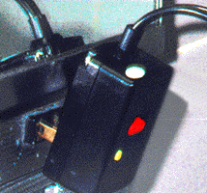

**Problem –**

This is a Plug type that is mainly used in Europe, but it can also be found in India mainly with SMPS, but this type of plug is not supported by Indian Switch Boards.

**Solution –**

If a SMPS company is selling its product in a country then it should atleast check the essential details that are required to use its products in that country and make changes if needed.

1. **What is the meaning of the symbols**

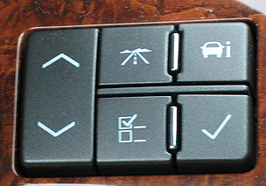

**Problem –**

The symbols on these buttons do not make any sense, it will confuse the driver while driving.

**Solution –**

The symbols on the button should be something that makes sense as to what the button is used for.

1. **Which number means what ?**

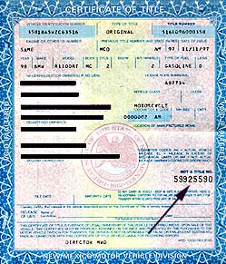

**Solution –**

Many of the documents we use have many different numbers on it and it is difficult to understand what each number is used for.

**Solution –**

There should be some label before the number indicating what that number means.

e.g seat number - 12345